Lettuce Yield Prediction — Progress Report
Generated on: 2026-09-04 16:18:12

1. Executive Summary
This report summarizes the completed image segmentation comparison, tray- and plant-level yield-prediction baselines, a mechanistic crop-model + residual hybrid ML stage, and an early-warning classifier for hydroponic lettuce. We compared three segmentation methods on matched timelapse frames, selected FastSAM for feature extraction, evaluated multiple regressors on harvest checkpoints, introduced a physics-based Van Henten / Farquhar crop model whose residuals are a target for image and sensor ML, and tested DAT ≤ 12 features for flagging plants that finish below the 227 g target (Section 8). Crop-model and ML metrics are reported separately in Section 7; trajectory overlays are in the figures.

2. Segmentation: Methods and Results

2.1 Methods Compared
We compared the following segmentation approaches (no dataset-specific fine-tuning):
- FastSAM (Fast Segment Anything): zero-shot instance segmentation optimized for speed.
- SAM (Segment Anything Model): zero-shot foundation-model segmentation.
- ExGR + Otsu + connected components: classical vegetation-index thresholding baseline.

2.2 Evaluation Setup
All three methods were evaluated on the same 53 matched frames (one frame per trial-day). Identical post-processing was applied to all methods (mask-size filtering and plant/pipe rejection heuristics) to ensure a fair comparison. Reported overlap metrics (Dice/IoU) quantify agreement between methods, not absolute accuracy against manual ground truth.

2.3 Quantitative Segmentation Results (Aggregate Means)
Segmentation comparison summary:
method | n_images | mean_time_sec | mean_raw_masks | mean_plant_crops | mean_plant_coverage_frac | mean_plant_color_frac | composite_score
fastsam | 53 | 1.525 | 32.00 | 20.98 | 0.1286 | 0.6414 | 0.7465
exgr | 53 | 0.600 | 23.04 | 17.11 | 0.0614 | 0.7105 | 0.6908
sam | 53 | 4.552 | 31.60 | 21.68 | 0.1123 | 0.6709 | 0.6633

2.4 Pairwise Mask Agreement (Dice and IoU)
Dice and IoU were computed on the union of accepted plant masks for each frame, comparing methods pairwise across the same 53 images. These values measure inter-method agreement (how similarly two methods label plant regions), not accuracy against manual ground truth.
Mean Dice and IoU between segmentation methods:
method_pair | mean_dice | mean_iou | n_frames
FastSAM vs SAM | 0.603 | 0.452 | 53
FastSAM vs ExGR | 0.133 | 0.074 | 53
ExGR vs SAM | 0.187 | 0.106 | 53

FastSAM and SAM show substantially higher agreement with each other (Dice 0.603, IoU 0.452) than either does with the classical ExGR baseline (IoU below 0.11 for both pairs).

2.5 Segmentation Conclusion
FastSAM was selected for downstream yield prediction because it achieved the highest canopy coverage while maintaining strong agreement with SAM and substantially faster runtime than SAM. ExGR was kept as a classical baseline but captured lower canopy coverage in dense tray imagery.

3. Yield Prediction: Models and Results
We evaluated multiple regressors using leave-one-out (LOO) validation on 8 harvest checkpoints per trial. Results are exploratory due to small sample size.
Three input feature sets were compared: image-only (FastSAM canopy size, color, and window growth); compact image + sensors (those image features plus window-average climate, nutrient, and actuator signals); and the full feature set (the same sources with window min/max/std statistics in addition to means).

3.1 Results for Trial1

Image-only features
Best model: XGBoost (MAE=42.00 g, R²=0.399).
Leave-one-out validation results (image-only features):
model | n_features | mae_g | rmse_g | r2
XGBoost | 68 | 42.00 | 54.48 | 0.399
GradBoost | 68 | 43.67 | 59.29 | 0.288
RandomForest | 68 | 50.68 | 64.61 | 0.154
ElasticNet | 68 | 54.23 | 70.81 | -0.016
SVR-RBF | 68 | 56.30 | 79.72 | -0.288
Ridge | 68 | 56.32 | 71.23 | -0.028

Compact (image + sensors)
Best model: GradBoost (MAE=36.72 g, R²=0.493).
Leave-one-out validation results (compact (image + sensors)):
model | n_features | mae_g | rmse_g | r2
GradBoost | 153 | 36.72 | 50.04 | 0.493
RandomForest | 153 | 44.50 | 59.02 | 0.294
Ridge | 153 | 47.12 | 65.22 | 0.138
ElasticNet | 153 | 49.29 | 67.31 | 0.082
XGBoost | 153 | 55.64 | 59.60 | 0.280
SVR-RBF | 153 | 57.94 | 81.11 | -0.333

Full feature set
Best model: XGBoost (MAE=31.71 g, R²=0.640).
Leave-one-out validation results (full feature set):
model | n_features | mae_g | rmse_g | r2
XGBoost | 557 | 31.71 | 42.14 | 0.640
ElasticNet | 557 | 31.93 | 50.43 | 0.485
Ridge | 557 | 32.83 | 54.69 | 0.394
GradBoost | 557 | 42.12 | 59.40 | 0.285
RandomForest | 557 | 45.67 | 60.58 | 0.256
SVR-RBF | 557 | 57.92 | 80.75 | -0.321

3.2 Results for Trial2

Image-only features
Best model: GradBoost (MAE=40.80 g, R²=-0.044).
Leave-one-out validation results (image-only features):
model | n_features | mae_g | rmse_g | r2
GradBoost | 68 | 40.80 | 71.79 | -0.044
RandomForest | 68 | 50.59 | 73.68 | -0.100
SVR-RBF | 68 | 57.84 | 82.17 | -0.368
XGBoost | 68 | 65.09 | 88.28 | -0.579
Ridge | 68 | 122.56 | 166.34 | -4.606
ElasticNet | 68 | 238.20 | 345.67 | -23.208

Compact (image + sensors)
Best model: XGBoost (MAE=28.37 g, R²=0.633).
Leave-one-out validation results (compact (image + sensors)):
model | n_features | mae_g | rmse_g | r2
XGBoost | 46 | 28.37 | 42.56 | 0.633
Ridge | 46 | 46.46 | 71.71 | -0.042
GradBoost | 46 | 47.29 | 77.77 | -0.225
SVR-RBF | 46 | 56.59 | 81.92 | -0.360
RandomForest | 46 | 62.08 | 79.59 | -0.283
ElasticNet | 46 | 71.29 | 90.04 | -0.643

Full feature set
Best model: GradBoost (MAE=31.84 g, R²=0.146).
Leave-one-out validation results (full feature set):
model | n_features | mae_g | rmse_g | r2
GradBoost | 557 | 31.84 | 64.93 | 0.146
XGBoost | 557 | 40.54 | 70.43 | -0.005
RandomForest | 557 | 41.97 | 66.64 | 0.100
SVR-RBF | 557 | 56.81 | 80.93 | -0.327
Ridge | 557 | 62.62 | 85.41 | -0.478
ElasticNet | 557 | 73.51 | 97.89 | -0.942

4. Selected Configuration for Next Phase
For direct ML yield prediction (Sections 3–6), we recommend the compact feature set (image + sensors) as the primary configuration, with image-only as an ablation and FastSAM as the segmentation method. For the physics + ML path (Section 7), keep the crop model as the tray-level baseline and report hybrid residual ML with compact features, using LODO within a trial and Trial-1→Trial-2 hold-out as the generalization check. For early warning (Section 8), report leave-one-plant-out results at the 10% below-target threshold (where Trial 1 has positive labels), alongside the official 20% definition and tray-level DAT-12 rules.

5. Notes / Limitations
- Only 8 labeled harvest checkpoints are available per trial; metrics are therefore high-variance and should be interpreted as exploratory.
- Segmentation overlap metrics (Dice/IoU) reported here measure agreement between methods; manual ground-truth masks are required for absolute segmentation accuracy (mIoU/Dice vs ground truth).
- Trial 2 labels may be protocol-shifted relative to Trial 1; cross-trial comparisons should be interpreted cautiously.
- Crop-model absolute grams depend on assumed bench area, dry-matter fraction (4.5%), and reconstructed PPFD (not logged). See Section 7.
- Early-warning (Section 8): Trial 1 has no plants ≥20% below 227 g, so the official Aim-3 label cannot yet be scored at plant level; 10%/15% thresholds are sensitivity checks with 2 and 1 positives.

6. Plant-Level Yield Prediction (Trial 1)
Sections 3–5 report tray-median models (one row per harvest day). This section adds a follow-on experiment that uses each weighed plant as its own training example. Existing checkpoint tables and the results in Section 3 were not modified.

6.1 Setup
The fresh-weight tracker already records New Fresh Weight (g) for Plant-IDs 1–10 on harvest days 0, 4, 8, 12, 16, 20, 24, and 28. The tray-median pipeline collapsed those 10 weights to one number per day (8 rows). Here, each plant-day is kept as a separate row. The target is that plant’s own fresh weight (target_fw_g), not the tray median.
This yields 79 labeled rows for Trial 1 (10 plants × 8 harvest days, except Day 8 is missing Plant 10, and a duplicate Plant-6 entry on Day 8 was averaged). Climate, nutrient, and actuator features are shared across plants on the same day (one tent). A plant-specific FastSAM cup image was attached when Plant-ID matched a camera cup_id in the same 4-day window (38 of 79 rows). Trial 2 is not included: it has no independent per-plant weights.
Four input sets were exported (new files only, under ml/plant/):
- Sensors: climate, nutrient, and actuator window features, plus plant ID and experimental day.
- Image: tray-level FastSAM canopy features plus plant-level cup image features when available.
- Compact: image features plus window-average sensors (same recipe as Section 3, expanded to plants).
- Full: all numeric window statistics plus plant-level image columns.

6.2 Validation
Two splits were run. Leave-one-out (LOO) hides one plant on one day but still shows the other plants from that same harvest day and the same plant on neighboring days, so it can look unrealistically good. Leave-one-harvest-day-out (LODO) hides all plants from one weighing day and trains on the other seven days. LODO is the fairer test of predicting a harvest that has not yet been seen, and is the result that should be used for comparison with Section 3.
A mean baseline (predict the average weight of the training plants) has LODO MAE ≈ 67 g. Model MAE should be read against that number.

6.3 Leave-One-Harvest-Day-Out Results (Fair Comparison)

Image-only features
Best model: XGBoost (plant MAE=28.64 g, R²=0.672, day-median MAE=28.32 g).
Leave-one-harvest-day-out results (image-only features):
model | n_features | mae_g | rmse_g | r2 | day_median_mae_g
XGBoost | 78 | 28.64 | 40.05 | 0.672 | 28.32
GradBoost | 78 | 45.04 | 60.23 | 0.258 | 44.96
ElasticNet | 78 | 49.43 | 59.89 | 0.267 | 49.40
Ridge | 78 | 51.07 | 62.23 | 0.208 | 50.61
RandomForest | 78 | 52.19 | 65.13 | 0.133 | 52.37
SVR-RBF | 78 | 58.03 | 72.25 | -0.067 | 57.42

Sensors-only features
Best model: XGBoost (plant MAE=23.60 g, R²=0.754, day-median MAE=23.74 g).
Leave-one-harvest-day-out results (sensors-only features):
model | n_features | mae_g | rmse_g | r2 | day_median_mae_g
XGBoost | 217 | 23.60 | 34.66 | 0.754 | 23.74
RandomForest | 217 | 35.02 | 50.74 | 0.473 | 35.81
GradBoost | 217 | 35.74 | 55.93 | 0.360 | 35.99
ElasticNet | 217 | 42.28 | 68.33 | 0.045 | 42.75
Ridge | 217 | 42.39 | 69.94 | -0.000 | 42.41
SVR-RBF | 217 | 59.52 | 72.38 | -0.071 | 59.22

Compact (image + sensors)
Best model: XGBoost (plant MAE=23.34 g, R²=0.752, day-median MAE=23.57 g).
Leave-one-harvest-day-out results (compact (image + sensors)):
model | n_features | mae_g | rmse_g | r2 | day_median_mae_g
XGBoost | 163 | 23.34 | 34.80 | 0.752 | 23.57
RandomForest | 163 | 35.89 | 53.92 | 0.406 | 35.71
GradBoost | 163 | 43.81 | 63.08 | 0.186 | 44.64
ElasticNet | 163 | 49.74 | 64.12 | 0.159 | 50.14
Ridge | 163 | 50.24 | 65.62 | 0.119 | 50.41
SVR-RBF | 163 | 62.03 | 75.81 | -0.175 | 62.27

Full feature set
Best model: XGBoost (plant MAE=23.15 g, R²=0.766, day-median MAE=23.25 g).
Leave-one-harvest-day-out results (full feature set):
model | n_features | mae_g | rmse_g | r2 | day_median_mae_g
XGBoost | 294 | 23.15 | 33.83 | 0.766 | 23.25
GradBoost | 294 | 35.27 | 49.48 | 0.499 | 35.92
ElasticNet | 294 | 35.51 | 53.25 | 0.420 | 36.17
RandomForest | 294 | 36.17 | 54.47 | 0.393 | 35.66
Ridge | 294 | 36.79 | 55.61 | 0.368 | 36.46
SVR-RBF | 294 | 65.35 | 77.75 | -0.236 | 65.51

6.4 Comparison with Tray-Median Models
On LODO, compact / sensors / full are essentially tied (best plant MAE 23.2–23.6 g, R² ≈ 0.75). Image-only is weaker (28.6 g), consistent with missing cup matches on many harvest windows. The extra columns in the full set do not improve accuracy over compact. Relative to Section 3.1 tray-median LOO (compact MAE 36.7 g; full MAE 31.7 g), the plant-level LODO error is lower, mainly because 79 plant-days provide more labeled rows than 8 tray medians.
Plant-level leave-one-out (optimistic; not used for model selection):
input | model | mae_g | r2
Image-only | GradBoost | 5.31 | 0.987
Sensors-only | XGBoost | 3.38 | 0.995
Compact | GradBoost | 5.37 | 0.987
Full | GradBoost | 5.34 | 0.987

Those LOO figures (MAE ≈ 3–5 g) should not be treated as the headline result: the model can still see other plants from the same day and the same plant on adjacent harvests, so it is largely interpolating the growth curve.

6.5 Interpretation and Selected Configuration
For the next phase we keep the compact (image + sensors) set as the primary plant-level configuration, with XGBoost and leave-one-harvest-day-out as the reported metric. Compact matches the recommendation in Section 4, remains as accurate as the full dump, and still includes both cameras and environment. Sensors-only should be retained as an ablation: it is nearly identical to compact on LODO, which suggests that much of the plant-level signal is environment plus plant age rather than the extra photo columns. Image-only is kept only as a vision baseline.
- Plant-ID is used as a feature, so these models describe the 10 weighed plants rather than unseen cups.
- Cup image attachment assumes Plant-ID equals camera cup_id; that mapping has not been verified on the bench.
- All 10 plants share the same tent climate on a given day, so extra rows help image-to-weight modeling more than they create independent environment experiments.
- The target is still same-window (current harvest) weight, not a forecast of the next checkpoint.

6.6 Summary: Best Model by Feature Set
The table below lists only the best model for each input set. The 8-row results are the tray-median leave-one-out numbers from Section 3. The 79-row results are the plant-level leave-one-harvest-day-out numbers from Section 6.3 (the fair plant-level split). Trial 2 8-row targets are the protocol-shifted Trial 1 medians.
Best model per feature set:
dataset | feature_set | split | best_model | n_features | mae_g | r2
Trial 1 tray-median (8 rows) | Image-only | LOO | XGBoost | 68 | 42.00 | 0.399
Trial 1 tray-median (8 rows) | Compact | LOO | GradBoost | 153 | 36.72 | 0.493
Trial 1 tray-median (8 rows) | Full | LOO | XGBoost | 557 | 31.71 | 0.640
Trial 2 tray-median (8 rows) | Image-only | LOO | GradBoost | 68 | 40.80 | -0.044
Trial 2 tray-median (8 rows) | Compact | LOO | XGBoost | 46 | 28.37 | 0.633
Trial 2 tray-median (8 rows) | Full | LOO | GradBoost | 557 | 31.84 | 0.146
Trial 1 plant-level (79 rows) | Image-only | LODO | XGBoost | 78 | 28.64 | 0.672
Trial 1 plant-level (79 rows) | Sensors-only | LODO | XGBoost | 217 | 23.60 | 0.754
Trial 1 plant-level (79 rows) | Compact | LODO | XGBoost | 163 | 23.34 | 0.752
Trial 1 plant-level (79 rows) | Full | LODO | XGBoost | 294 | 23.15 | 0.766

MAE is in grams. Lower MAE and higher R² are better. LOO and LODO are different tests, so 8-row and 79-row MAE values are not strictly interchangeable; the table is a compact scoreboard, not a claim that the splits are identical.

7. Mechanistic Crop Model and Residual Hybrid ML
Sections 3 and 6 train ML models to predict fresh weight directly from images and sensors. This section adds a different baseline: a physics-based lettuce crop model (Van Henten growth structure with Farquhar–von Caemmerer–Berry photosynthesis) that predicts expected tray-median weight from light, temperature, CO₂, and humidity only. Nutrients/EC are deliberately left out of the crop model so that the residual (observed − modelled) is a clean target for image and EC analysis. We then compare three approaches on the same harvest checkpoints: crop model alone, ML predicting raw weight, and hybrid ML that predicts the residual and adds it back to the crop prediction.

7.1 Crop Model Setup
Daily driver tables were built from Mycodo exports in Data collection/ (with CO₂ QC that drops implausible readings). PPFD was reconstructed from the documented light schedule because no PAR sensor was logged. One free parameter (canopy_efficiency) was fitted per trial by least squares in log fresh weight against the 4-day weigh-ins; all other physiology coefficients stay at literature or measured values.
- Trial 1: adaptive EC steering; PPFD step 200 → 445 µmol m⁻² s⁻¹ at DAT 12.
- Trial 2: fixed EC 1.4–1.6 mS/cm; constant ~445 µmol m⁻² s⁻¹.
- Outputs: Lettuce_model/Python/outputs/ (simulation CSVs, fit tables, growth_trajectories.png, summary.json).

7.2 Crop Model Fit Metrics
Crop-model calibration and checkpoint metrics (DAT 4–28; DAT 0 excluded from fit):
trial | canopy_efficiency | MAE_g | RMSE_g | MAPE_pct | R2 | bias_g | harvest_obs_g | harvest_model_g
Trial 1 | 1.416 | 9.39 | 10.94 | 18.9 | 0.976 | -0.70 | 219.8 | 201.4
Trial 2 | 0.992 | 10.49 | 13.29 | 21.2 | 0.945 | 2.20 | 179.8 | 150.9

Observed harvest difference (Trial 1 − Trial 2) is +40.0 g; the crop model difference is +50.5 g. So the light schedule alone is enough for the physics model to explain the full cross-trial harvest gap before EC is invoked. Both trials show the same residual shape: model ahead mid-cycle (DAT 16–20) and behind at harvest — a repeatable miss that residual ML is asked to explain.

7.3 Checkpoint Residuals (Observed − Modelled)
Trial 1 crop-model fit at harvest checkpoints:
DAT | observed_g | modelled_g | residual_g | residual_pct | target_mid_g
0 | 4.7 | 4.5 | 0.2 | 3.8 | 3.5
4 | 13.1 | 8.2 | 4.9 | 37.7 | 8.8
8 | 19.8 | 14.0 | 5.8 | 29.5 | 22.2
12 | 27.3 | 26.0 | 1.3 | 4.9 | 56.0
16 | 42.3 | 53.9 | -11.6 | -27.4 | 98.8
20 | 80.8 | 96.2 | -15.4 | -19.1 | 141.5
24 | 139.3 | 147.6 | -8.3 | -5.9 | 184.3
28 | 219.8 | 201.4 | 18.4 | 8.4 | 227.0

Trial 2 crop-model fit at harvest checkpoints:
DAT | observed_g | modelled_g | residual_g | residual_pct | target_mid_g
0 | 4.7 | 4.5 | 0.2 | 3.8 | 3.5
4 | 17.8 | 9.4 | 8.4 | 47.2 | 8.8
8 | 20.8 | 17.4 | 3.4 | 16.6 | 22.2
12 | 26.3 | 31.9 | -5.6 | -21.2 | 56.0
16 | 41.8 | 53.6 | -11.8 | -28.3 | 98.8
20 | 70.8 | 82.4 | -11.6 | -16.4 | 141.5
24 | 119.3 | 115.6 | 3.7 | 3.1 | 184.3
28 | 179.8 | 150.9 | 28.9 | 16.1 | 227.0

7.4 Crop Model Trajectory Figures
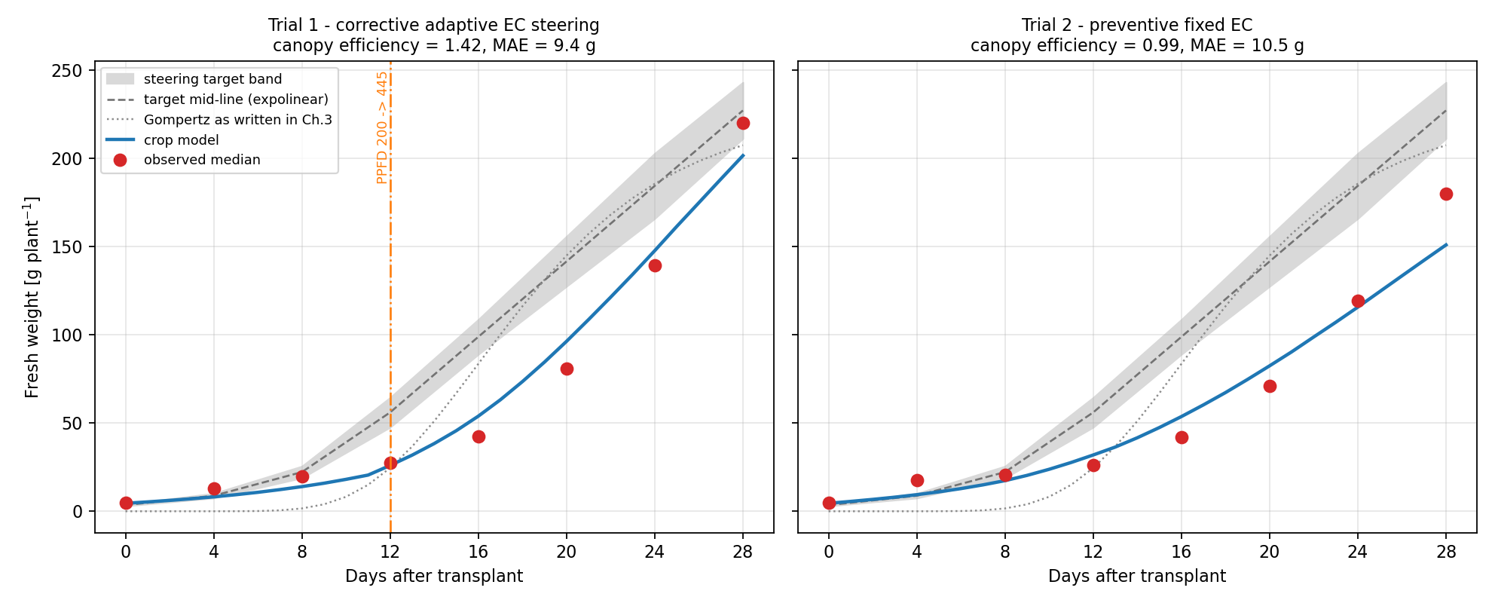
Figure 7.1. Crop-model growth trajectories vs observed medians and steering band (Lettuce_model/Python/outputs/growth_trajectories.png).

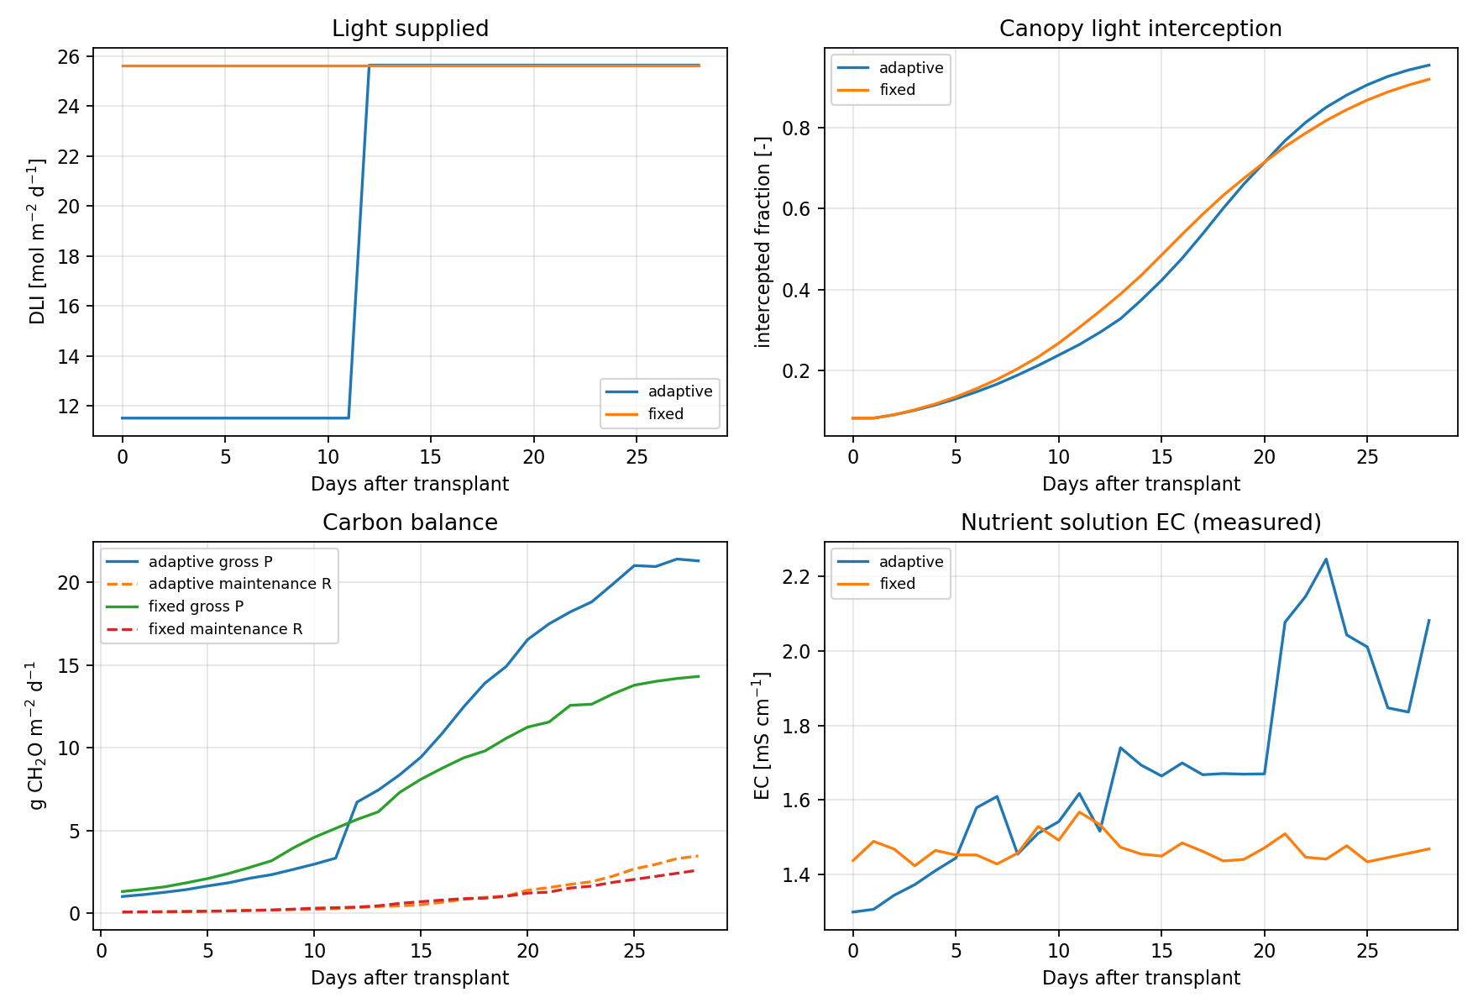
Figure 7.2. Crop-model carbon balance and related drivers (Lettuce_model/Python/outputs/carbon_balance.png).

7.5 Tray-Level ML Results (8 Checkpoints, LODO)
Crop-model metrics for these same checkpoints are reported in Section 7.2 (Trial 1 MAE 9.39 g; Trial 2 MAE 10.49 g). The tables below list ML results only. Visual side-by-side trajectories and error plots are in Section 7.8.
Two ML setups were trained with leave-one-harvest-day-out (LODO): (1) raw weight — ML predicts observed grams from image/sensor window features; (2) hybrid residual — ML predicts residual_g, then final weight = modelled_g + predicted residual. Feature variants: image-only, compact (image + sensors), and sensors-only. Each row is the best model (lowest MAE) for that trial × feature set.
ML predicting raw fresh weight (LODO; best model per feature set):
trial | feature_set | best_model | n_features | mae_g | rmse_g | r2
trial1 | image | XGBoost | 68 | 28.30 | 39.74 | 0.684
trial1 | compact | XGBoost | 153 | 24.40 | 36.19 | 0.738
trial1 | sensors | XGBoost | 216 | 23.69 | 35.38 | 0.749
trial2 | image | GradBoost | 66 | 32.74 | 57.85 | -0.037

Hybrid residual ML (LODO; best model per feature set):
trial | feature_set | best_model | n_features | mae_g | rmse_g | r2
trial1 | image | SVR-RBF | 68 | 9.41 | 11.35 | 0.974
trial1 | compact | SVR-RBF | 153 | 9.67 | 11.41 | 0.974
trial1 | sensors | SVR-RBF | 216 | 9.56 | 11.46 | 0.974
trial2 | image | RandomForest | 66 | 9.02 | 13.42 | 0.944

7.6 Hold-Out Results (Train Trial 1 → Test Trial 2)
Models were trained on all Trial 1 checkpoints and evaluated on Trial 2 using compact (image + sensor) features. Crop-model Trial 2 MAE is again the Section 7.2 value (10.49 g). ML results for this hold-out are listed below; see Figure 7.7 for trajectories.
Hold-out Trial 2 — ML predicting raw fresh weight (compact features):
model | n_features | mae_g | rmse_g | r2
XGBoost | 153 | 3.76 | 5.02 | 0.992
SVR-RBF | 153 | 42.95 | 62.92 | -0.226
RandomForest | 153 | 45.87 | 62.81 | -0.222
GradBoost | 153 | 50.66 | 67.12 | -0.395
Ridge | 153 | 54.46 | 62.79 | -0.221
ElasticNet | 153 | 55.66 | 64.14 | -0.274

Hold-out Trial 2 — hybrid residual ML (compact features):
model | n_features | mae_g | rmse_g | r2
ElasticNet | 153 | 7.92 | 11.52 | 0.959
Ridge | 153 | 7.99 | 11.51 | 0.959
XGBoost | 153 | 8.78 | 11.23 | 0.961
GradBoost | 153 | 8.96 | 12.18 | 0.954
RandomForest | 153 | 9.15 | 12.60 | 0.951
SVR-RBF | 153 | 9.75 | 13.06 | 0.947

7.7 Plant-Level ML Results (79 Rows, Trial 1 LODO)
Each row is one weighed plant on one harvest day (target_fw_g). The crop prior used inside the hybrid setup is the tray-level modelled_g from Section 7.2 (crop-model Trial 1 MAE 9.39 g on tray medians). Tables below report ML metrics only.
Plant-level LODO — ML predicting raw plant fresh weight:
feature_set | best_model | n_features | mae_g | rmse_g | r2
image | XGBoost | 78 | 29.74 | 42.73 | 0.627
compact | XGBoost | 163 | 24.99 | 35.07 | 0.748
sensors | XGBoost | 219 | 24.58 | 34.34 | 0.759

Plant-level LODO — hybrid residual ML:
feature_set | best_model | n_features | mae_g | rmse_g | r2
image | RandomForest | 78 | 9.19 | 13.12 | 0.965
compact | RandomForest | 163 | 8.97 | 12.66 | 0.967
sensors | SVR-RBF | 219 | 9.47 | 12.48 | 0.968

Plant leave-one-out (LOO) MAE values of roughly 4–5 g appear in earlier plant-level runs but are optimistic (same-day plants remain visible) and are not used as the headline metric.

7.8 Figures (Crop Model and ML Together)
The following figures show crop-model and ML predictions on the same axes for visual comparison. Numeric results remain in the separate tables above.
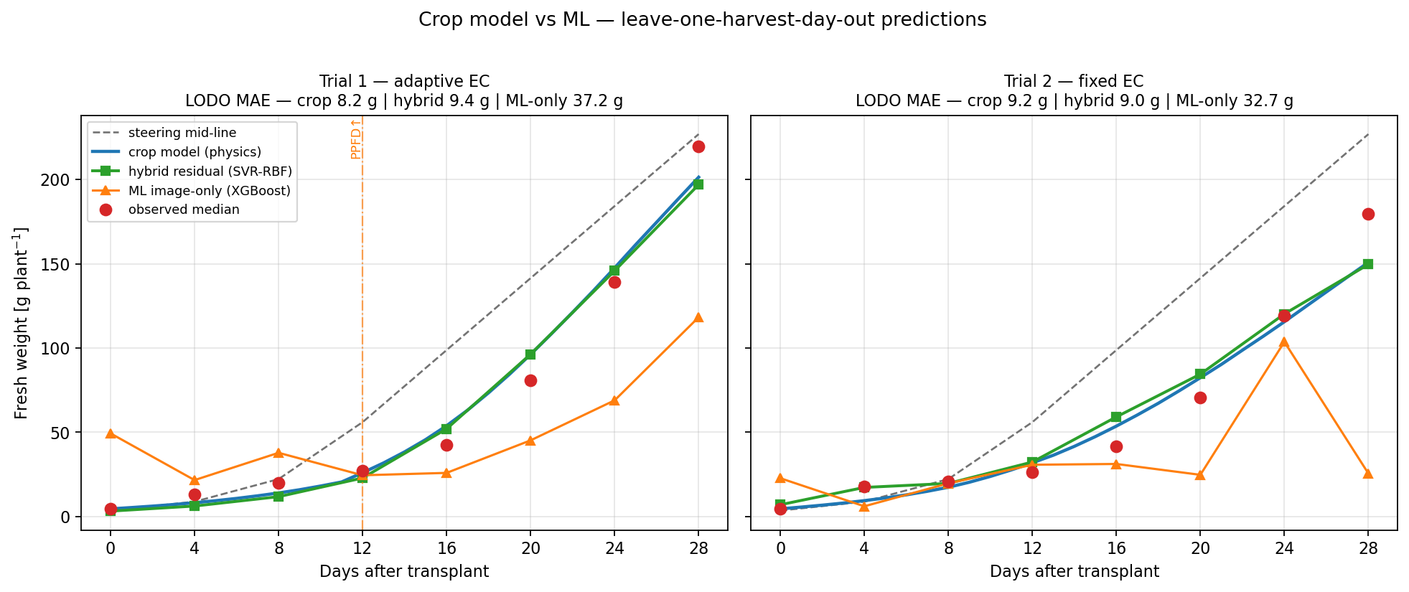
Figure 7.3. Growth trajectories: observed vs crop model vs hybrid residual ML vs image-only ML (leave-one-harvest-day-out).

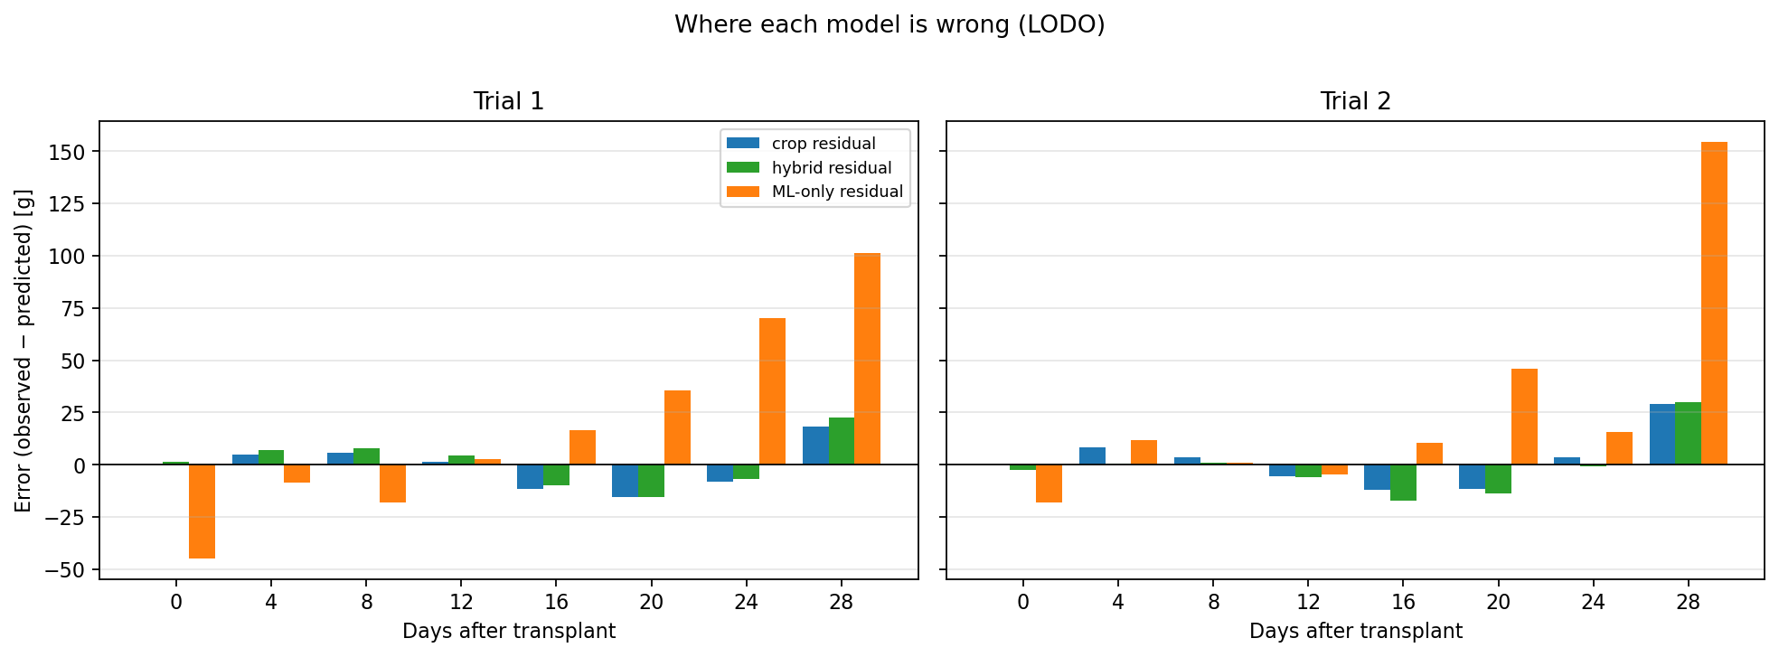
Figure 7.4. Prediction residuals by harvest day for crop, hybrid, and ML-only models.

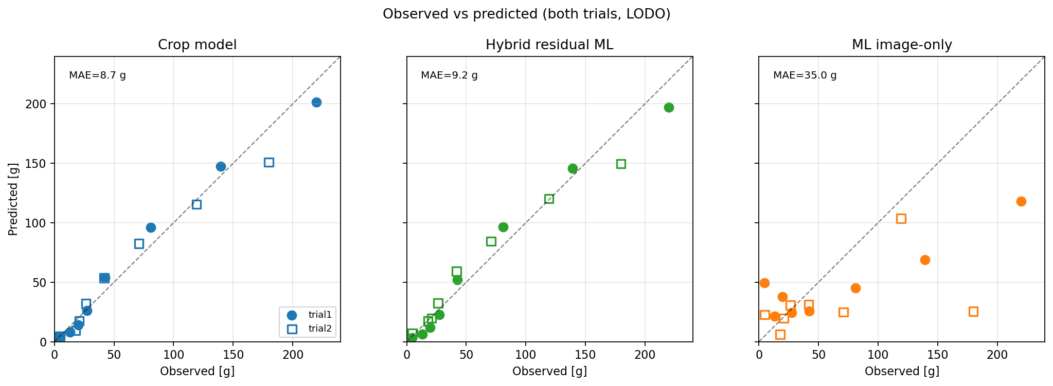
Figure 7.5. Observed vs predicted scatter for crop, hybrid, and ML-only (both trials, LODO).

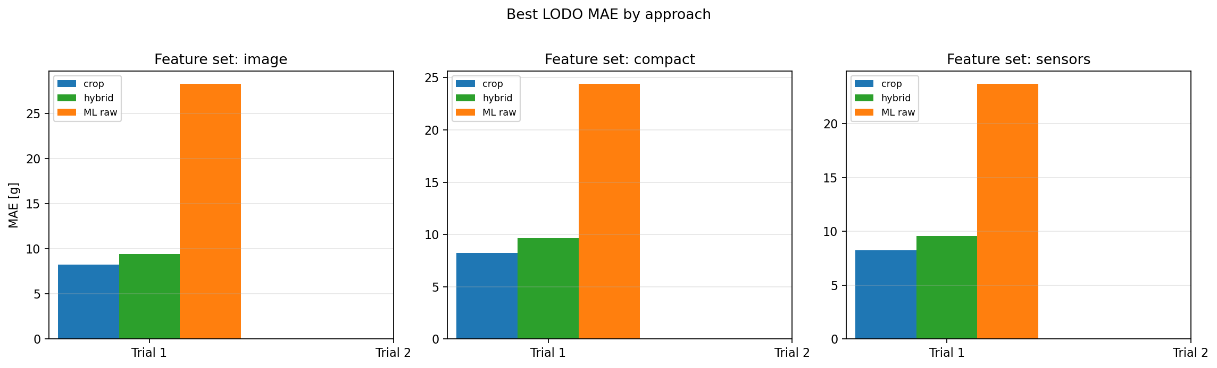
Figure 7.6. Best LODO MAE by feature set (image / compact / sensors).

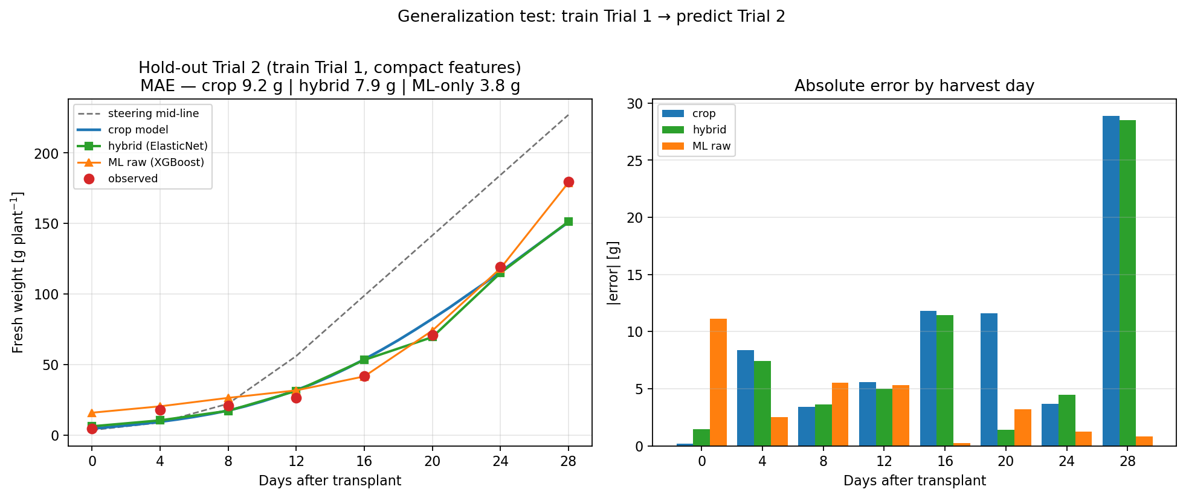
Figure 7.7. Hold-out: train Trial 1 → predict Trial 2 (compact features).

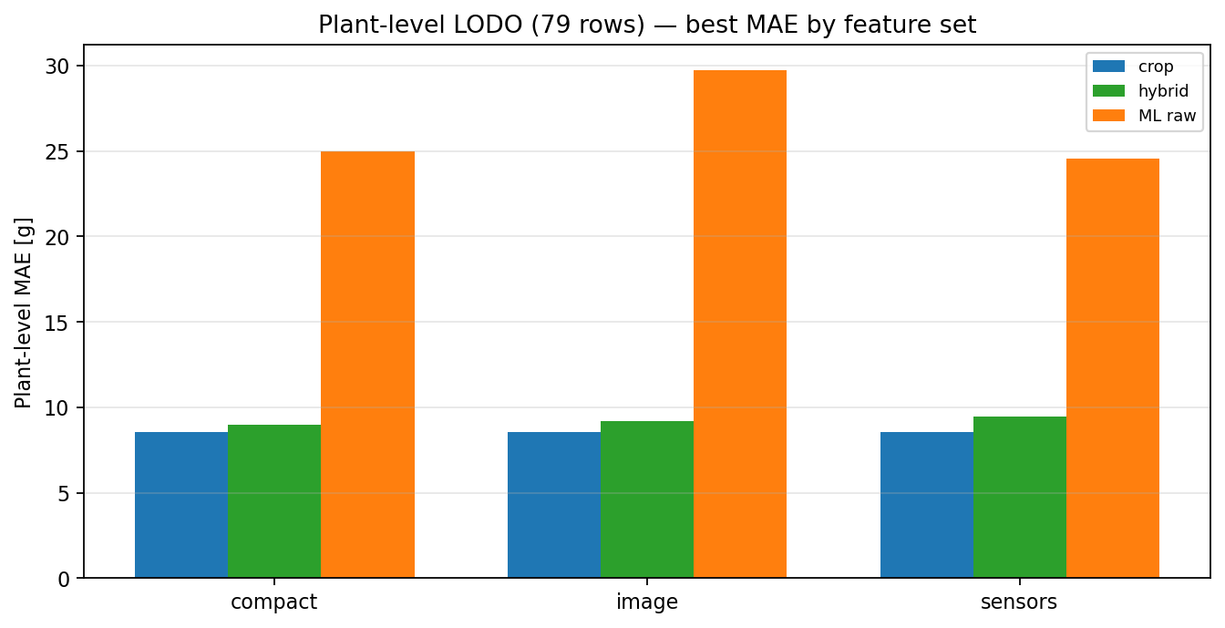
Figure 7.8. Plant-level LODO MAE by feature set (79 plant-days).

7.9 Interpretation and Next Steps
- Crop model (Section 7.2): tray-level MAE ~8–10 g, R² ≈ 0.95–0.98, without images or EC.
- ML raw weight models: higher LODO MAE on 8 tray checkpoints; see tables in 7.5.
- Hybrid residual ML: LODO and hold-out results in 7.5–7.6; trajectory overlays in 7.8.
- Early-warning classification (Aim 3) is reported in Section 8.
- Known crop-model limitations: assumed bench area, dry-matter fraction 4.5%, unlogged PPFD, and only two sequential trials (not true replicates).

8. Early-Warning Classification (DAT ≤ 12)
This section addresses Aim 3 from the project direction: at DAT 12, can the system identify plants that will finish well below the 227 g target? Features use only information available by DAT ≤ 12 (early fresh weights at DAT 0/4/8/12, DAT-12 crop-model residual, and gap to the steering mid-line). The harvest-day label is not used as an input.

8.1 Label Definition
Shortfall label: harvest fresh weight ≤ 227 × (1 − pct_below). The professor definition uses pct_below = 20% (threshold ≈ 181.6 g). Trial 1 plant harvests never meet that cut (lightest plant ≈ 185.8 g, about 18% below target), so classifiers are also compared at 10% (≤ 204.3 g) and 15% (≤ 193.0 g), where positive examples exist.
Trial 1 plant-level shortfall counts (n = 10 plants):
threshold | cut_g | n_shortfall | n_ok | shortfall_plants
10% below | 204.3 | 2 | 8 | 5, 6
15% below | 193.0 | 1 | 9 | 5
20% below (official) | 181.6 | 0 | 10 | —

8.2 Methods
Validation is leave-one-plant-out. Two modes are compared: (1) direct classifiers (Dummy most-frequent, Logistic Regression, SVM-RBF, Random Forest, Gradient Boosting, XGBoost); (2) regress-then-threshold — predict DAT-28 grams from DAT ≤ 12 features, then apply the shortfall cut. Feature variants: compact, image, and sensors. Within a single trial, tent climate at DAT 12 is identical across plants, so plant discrimination is driven mainly by early weights and the crop-model residual.

8.3 Classifier Comparison (10% Below Target)
Primary comparable setting: 10% below 227 g (≤ 204.3 g; plants 5 and 6 labeled shortfall). Compact feature set; leave-one-plant-out.
Direct classifiers @ 10% shortfall threshold (compact features):
model | accuracy | precision | recall | f1 | balanced_acc | roc_auc
RandomForest | 0.90 | 1.00 | 0.50 | 0.67 | 0.75 | 0.50
GradBoost | 0.90 | 1.00 | 0.50 | 0.67 | 0.75 | 0.50
LogisticRegression | 0.80 | 0.50 | 0.50 | 0.50 | 0.69 | 0.75
DummyMostFrequent | 0.80 | — | 0.00 | — | 0.50 | 0.50
XGBoost | 0.80 | — | 0.00 | — | 0.50 | 0.00
SVM-RBF | 0.70 | 0.00 | 0.00 | — | 0.44 | 0.12

8.4 Regress-then-Threshold (10% Below Target)
Same label and split, but the model first predicts harvest grams from DAT ≤ 12 features, then warns if the prediction is ≤ 204.3 g. Harvest MAE is the leave-one-plant-out error of that gram forecast.
Regress-then-threshold @ 10% shortfall (compact features):
model | accuracy | precision | recall | f1 | roc_auc | harvest_mae_g
XGBoost | 0.90 | 1.00 | 0.50 | 0.67 | 0.88 | 6.77
Ridge | 0.90 | 1.00 | 0.50 | 0.67 | 0.75 | 7.47
RandomForest | 0.90 | 1.00 | 0.50 | 0.67 | 0.69 | 6.32
GradBoost | 0.90 | 1.00 | 0.50 | 0.67 | 0.69 | 6.87
ElasticNet | 0.70 | 0.33 | 0.50 | 0.40 | 0.88 | 10.22
SVR-RBF | 0.80 | — | 0.00 | — | 0.00 | 11.45

8.5 Official 20% Threshold and Tray Check
At the official ≥20% below-target rule, Trial 1 has zero shortfall plants, so plant-level precision/recall are undefined and “accuracy = 1.0” only means every model predicted no warning. Trial 2’s tray median (179.8 g) does meet the 20% shortfall label. Simple DAT-12 tray rules:
Tray-level descriptive rules at DAT 12 (20% shortfall label):
trial | harvest_observed_g | shortfall_20pct_label | dat12_observed_g | dat12_modelled_g | dat12_residual_g | rule_warn_if_dat12_below_target_mid_56 | rule_warn_if_dat12_residual_neg
trial1 | 219.8 | 0 | 27.3 | 26.0 | 1.3 | 1 | 0
trial2 | 179.8 | 1 | 26.3 | 31.9 | -5.6 | 1 | 1

Both trials are below the DAT-12 steering mid (56 g), so that rule alone false-alarms on Trial 1. A negative DAT-12 crop-model residual flags Trial 2 only, matching the true 20% harvest shortfall.

8.6 Interpretation
- Best direct classifier at 10%: RandomForest (F1=0.6667, precision=1.0, recall=0.5). Best regress-then-threshold: XGBoost (F1=0.6667, ROC-AUC=0.875, harvest MAE=6.7702 g).
- At 10%, top models catch 1 of 2 light plants with no false alarms (precision 1.0, recall 0.5, F1 ≈ 0.67).
- At 15% (only plant 5 positive), classifiers generally fail to recover that single case under leave-one-plant-out.
- The official 20% Aim-3 definition needs more shortfall examples (e.g. Trial 2 plant weights, or a third trial) before it can be scored as a plant-level classifier.
- Outputs: ml/early_warning/ (results_early_warning_comparison.csv, predictions_early_warning_loo.csv).

